1 run......

training 1 epoch...

10.516783952713013 seconds used......

1 training finished! average train loss: 1.0064113682934217

evaluating...

Confusion matrix, without normalization

[[ 77 15 4]

[106 210 39]

[154 171 394]]

Normalized confusion matrix

[[0.80208333 0.15625 0.04166667]

[0.29859155 0.5915493 0.10985915]

[0.21418637 0.23783032 0.54798331]]

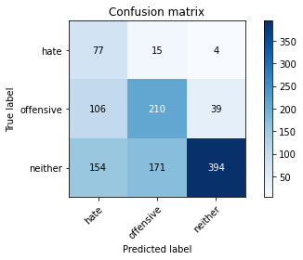

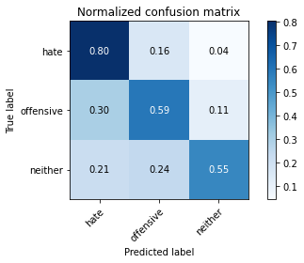

precision recall f1-score support

hate 0.23 0.80 0.36 96

offensive 0.53 0.59 0.56 355

neither 0.90 0.55 0.68 719

accuracy 0.58 1170

macro avg 0.55 0.65 0.53 1170

weighted avg 0.73 0.58 0.62 1170

average eval_loss: 0.9017960984828108, accuracy: 0.5820512820512821

training 2 epoch...

10.610681772232056 seconds used......

2 training finished! average train loss: 0.6857035378260272

evaluating...

Confusion matrix, without normalization

[[ 73 13 10]

[ 74 227 54]

[ 67 156 496]]

Normalized confusion matrix

[[0.76041667 0.13541667 0.10416667]

[0.2084507 0.63943662 0.15211268]

[0.09318498 0.21696801 0.68984701]]

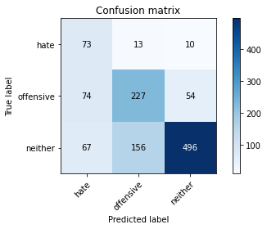

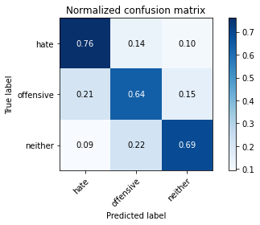

precision recall f1-score support

hate 0.34 0.76 0.47 96

offensive 0.57 0.64 0.60 355

neither 0.89 0.69 0.78 719

accuracy 0.68 1170

macro avg 0.60 0.70 0.62 1170

weighted avg 0.75 0.68 0.70 1170

average eval_loss: 0.745387683985597, accuracy: 0.6803418803418804

training 3 epoch...

10.668607950210571 seconds used......

3 training finished! average train loss: 0.4338673111051321

evaluating...

Confusion matrix, without normalization

[[ 77 10 9]

[ 89 197 69]

[ 78 86 555]]

Normalized confusion matrix

[[0.80208333 0.10416667 0.09375 ]

[0.25070423 0.55492958 0.1943662 ]

[0.10848401 0.11961057 0.77190542]]

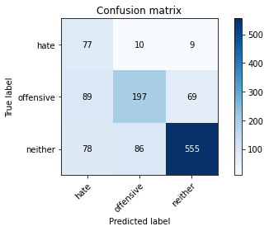

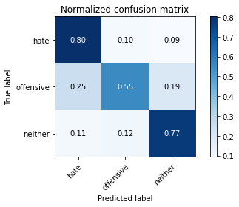

precision recall f1-score support

hate 0.32 0.80 0.45 96

offensive 0.67 0.55 0.61 355

neither 0.88 0.77 0.82 719

accuracy 0.71 1170

macro avg 0.62 0.71 0.63 1170

weighted avg 0.77 0.71 0.73 1170

average eval_loss: 0.7415856941271637, accuracy: 0.7085470085470086

training 4 epoch...

10.598674774169922 seconds used......

4 training finished! average train loss: 0.2008018085866102

evaluating...

Confusion matrix, without normalization

[[ 84 7 5]

[105 188 62]

[ 94 98 527]]

Normalized confusion matrix

[[0.875 0.07291667 0.05208333]

[0.29577465 0.52957746 0.17464789]

[0.13073713 0.13630042 0.73296245]]

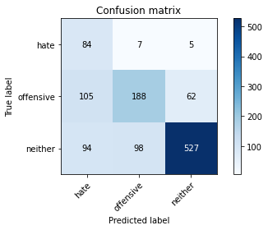

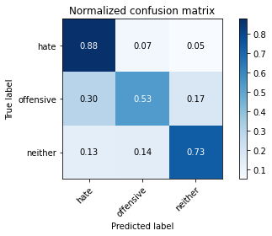

precision recall f1-score support

hate 0.30 0.88 0.44 96

offensive 0.64 0.53 0.58 355

neither 0.89 0.73 0.80 719

accuracy 0.68 1170

macro avg 0.61 0.71 0.61 1170

weighted avg 0.76 0.68 0.71 1170

average eval_loss: 0.9087118794352321, accuracy: 0.6829059829059829

training 5 epoch...

10.804059267044067 seconds used......

5 training finished! average train loss: 0.09901694654087935

evaluating...

Confusion matrix, without normalization

[[ 81 10 5]

[ 96 224 35]

[100 149 470]]

Normalized confusion matrix

[[0.84375 0.10416667 0.05208333]

[0.27042254 0.63098592 0.09859155]

[0.13908206 0.20723227 0.65368567]]

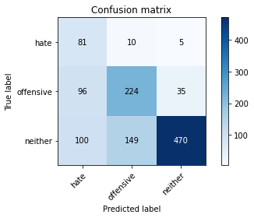

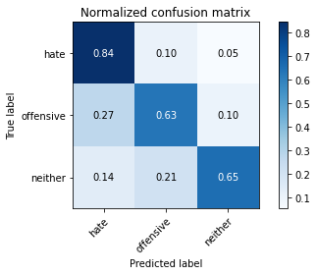

precision recall f1-score support

hate 0.29 0.84 0.43 96

offensive 0.58 0.63 0.61 355

neither 0.92 0.65 0.76 719

accuracy 0.66 1170

macro avg 0.60 0.71 0.60 1170

weighted avg 0.77 0.66 0.69 1170

average eval_loss: 1.1556406167604156, accuracy: 0.6623931623931624

training 6 epoch...

10.568740129470825 seconds used......

6 training finished! average train loss: 0.05685033070455704

evaluating...

Confusion matrix, without normalization

[[ 79 10 7]

[ 97 212 46]

[ 77 132 510]]

Normalized confusion matrix

[[0.82291667 0.10416667 0.07291667]

[0.27323944 0.5971831 0.12957746]

[0.10709318 0.18358832 0.7093185 ]]

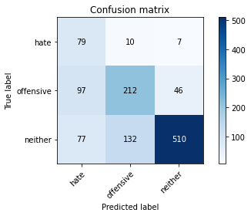

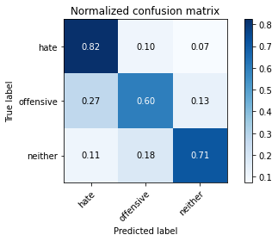

precision recall f1-score support

hate 0.31 0.82 0.45 96

offensive 0.60 0.60 0.60 355

neither 0.91 0.71 0.80 719

accuracy 0.68 1170

macro avg 0.61 0.71 0.62 1170

weighted avg 0.76 0.68 0.71 1170

average eval_loss: 1.1577238925432756, accuracy: 0.6846153846153846

training 7 epoch...

10.748136520385742 seconds used......

7 training finished! average train loss: 0.0376378827246039

evaluating...

Confusion matrix, without normalization

[[ 76 12 8]

[ 74 210 71]

[ 64 112 543]]

Normalized confusion matrix

[[0.79166667 0.125 0.08333333]

[0.2084507 0.5915493 0.2 ]

[0.08901252 0.15577191 0.75521558]]

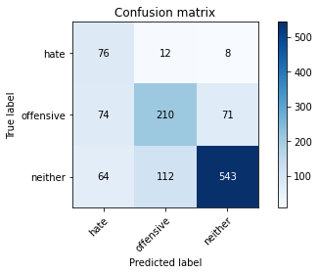

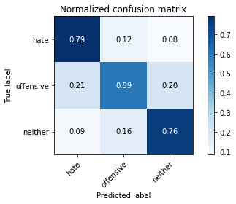

precision recall f1-score support

hate 0.36 0.79 0.49 96

offensive 0.63 0.59 0.61 355

neither 0.87 0.76 0.81 719

accuracy 0.71 1170

macro avg 0.62 0.71 0.64 1170

weighted avg 0.76 0.71 0.72 1170

average eval_loss: 1.0983679456225897, accuracy: 0.7085470085470086

training 8 epoch...

10.564720392227173 seconds used......

8 training finished! average train loss: 0.026785296142666733

evaluating...

Confusion matrix, without normalization

[[ 87 5 4]

[124 192 39]

[116 121 482]]

Normalized confusion matrix

[[0.90625 0.05208333 0.04166667]

[0.34929577 0.54084507 0.10985915]

[0.16133519 0.16828929 0.67037552]]

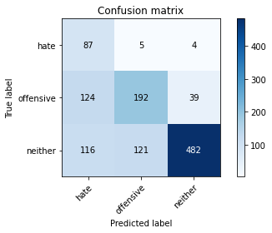

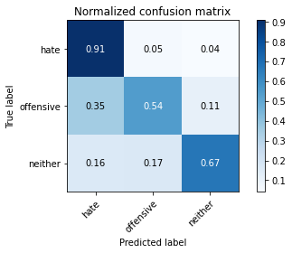

precision recall f1-score support

hate 0.27 0.91 0.41 96

offensive 0.60 0.54 0.57 355

neither 0.92 0.67 0.77 719

accuracy 0.65 1170

macro avg 0.60 0.71 0.59 1170

weighted avg 0.77 0.65 0.68 1170

average eval_loss: 1.5496159296924785, accuracy: 0.6504273504273504

training 9 epoch...

10.726680278778076 seconds used......

9 training finished! average train loss: 0.019428075420104766

evaluating...

Confusion matrix, without normalization

[[ 70 19 7]

[ 62 247 46]

[ 62 154 503]]

Normalized confusion matrix

[[0.72916667 0.19791667 0.07291667]

[0.17464789 0.69577465 0.12957746]

[0.08623088 0.21418637 0.69958275]]

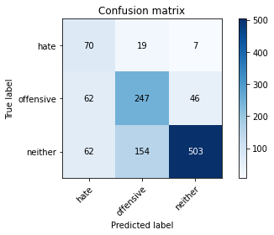

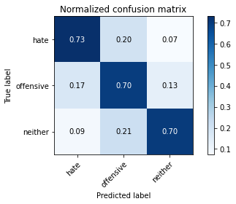

precision recall f1-score support

hate 0.36 0.73 0.48 96

offensive 0.59 0.70 0.64 355

neither 0.90 0.70 0.79 719

accuracy 0.70 1170

macro avg 0.62 0.71 0.64 1170

weighted avg 0.76 0.70 0.72 1170

average eval_loss: 1.2317959921339812, accuracy: 0.7008547008547008

training 10 epoch...

10.617806673049927 seconds used......

10 training finished! average train loss: 0.013773658608053145

evaluating...

Confusion matrix, without normalization

[[ 67 18 11]

[ 60 227 68]

[ 59 113 547]]

Normalized confusion matrix

[[0.69791667 0.1875 0.11458333]

[0.16901408 0.63943662 0.1915493 ]

[0.08205841 0.15716273 0.76077886]]

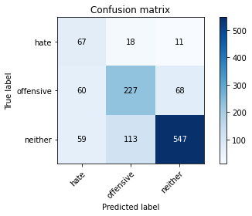

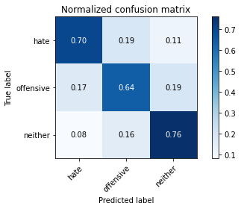

precision recall f1-score support

hate 0.36 0.70 0.48 96

offensive 0.63 0.64 0.64 355

neither 0.87 0.76 0.81 719

accuracy 0.72 1170

macro avg 0.62 0.70 0.64 1170

weighted avg 0.76 0.72 0.73 1170

average eval_loss: 1.2007080998461126, accuracy: 0.7188034188034188

2 run......

training 1 epoch...

10.761061906814575 seconds used......

1 training finished! average train loss: 1.0058337492602212

evaluating...

Confusion matrix, without normalization

[[ 69 7 20]

[118 113 124]

[ 72 38 609]]

Normalized confusion matrix

[[0.71875 0.07291667 0.20833333]

[0.33239437 0.31830986 0.34929577]

[0.10013908 0.05285118 0.84700974]]

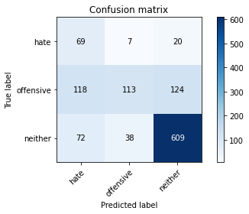

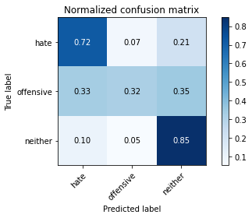

precision recall f1-score support

hate 0.27 0.72 0.39 96

offensive 0.72 0.32 0.44 355

neither 0.81 0.85 0.83 719

accuracy 0.68 1170

macro avg 0.60 0.63 0.55 1170

weighted avg 0.74 0.68 0.67 1170

average eval_loss: 0.7624929254337892, accuracy: 0.6760683760683761

training 2 epoch...

10.556472063064575 seconds used......

2 training finished! average train loss: 0.6929500810801983

evaluating...

Confusion matrix, without normalization

[[ 68 26 2]

[ 48 267 40]

[ 68 174 477]]

Normalized confusion matrix

[[0.70833333 0.27083333 0.02083333]

[0.13521127 0.75211268 0.11267606]

[0.0945758 0.24200278 0.66342142]]

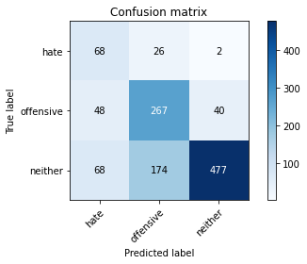

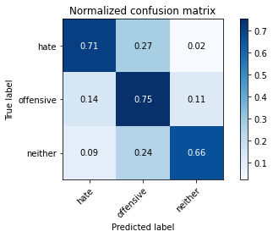

precision recall f1-score support

hate 0.37 0.71 0.49 96

offensive 0.57 0.75 0.65 355

neither 0.92 0.66 0.77 719

accuracy 0.69 1170

macro avg 0.62 0.71 0.64 1170

weighted avg 0.77 0.69 0.71 1170

average eval_loss: 0.708756470579212, accuracy: 0.694017094017094

training 3 epoch...

10.638009071350098 seconds used......

3 training finished! average train loss: 0.4299498357410942

evaluating...

Confusion matrix, without normalization

[[ 86 7 3]

[117 172 66]

[102 79 538]]

Normalized confusion matrix

[[0.89583333 0.07291667 0.03125 ]

[0.32957746 0.48450704 0.18591549]

[0.1418637 0.10987483 0.74826147]]

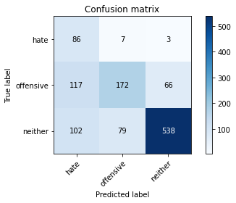

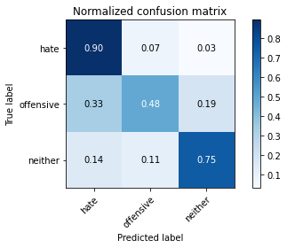

precision recall f1-score support

hate 0.28 0.90 0.43 96

offensive 0.67 0.48 0.56 355

neither 0.89 0.75 0.81 719

accuracy 0.68 1170

macro avg 0.61 0.71 0.60 1170

weighted avg 0.77 0.68 0.70 1170

average eval_loss: 0.8157590521594226, accuracy: 0.6803418803418804

training 4 epoch...

10.536639213562012 seconds used......

4 training finished! average train loss: 0.19436028080859355

evaluating...

Confusion matrix, without normalization

[[ 76 15 5]

[ 70 224 61]

[ 67 131 521]]

Normalized confusion matrix

[[0.79166667 0.15625 0.05208333]

[0.1971831 0.63098592 0.17183099]

[0.09318498 0.1821975 0.72461752]]

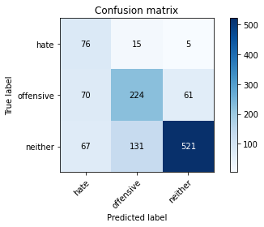

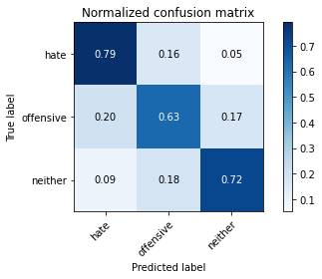

precision recall f1-score support

hate 0.36 0.79 0.49 96

offensive 0.61 0.63 0.62 355

neither 0.89 0.72 0.80 719

accuracy 0.70 1170

macro avg 0.62 0.72 0.64 1170

weighted avg 0.76 0.70 0.72 1170

average eval_loss: 0.912213655851655, accuracy: 0.7017094017094017

training 5 epoch...

10.578224420547485 seconds used......

5 training finished! average train loss: 0.10789605649188161

evaluating...

Confusion matrix, without normalization

[[ 68 21 7]

[ 52 236 67]

[ 58 116 545]]

Normalized confusion matrix

[[0.70833333 0.21875 0.07291667]

[0.14647887 0.66478873 0.18873239]

[0.08066759 0.16133519 0.75799722]]

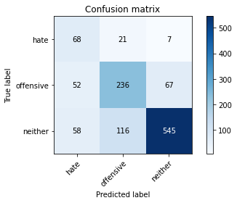

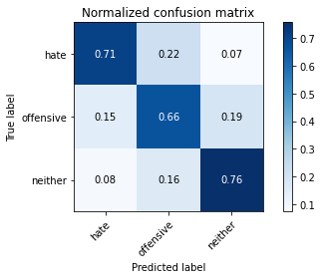

precision recall f1-score support

hate 0.38 0.71 0.50 96

offensive 0.63 0.66 0.65 355

neither 0.88 0.76 0.81 719

accuracy 0.73 1170

macro avg 0.63 0.71 0.65 1170

weighted avg 0.76 0.73 0.74 1170

average eval_loss: 0.9164980867151487, accuracy: 0.7256410256410256

training 6 epoch...

10.542088508605957 seconds used......

6 training finished! average train loss: 0.07441087881202943

evaluating...

Confusion matrix, without normalization

[[ 77 15 4]

[ 66 236 53]

[ 73 146 500]]

Normalized confusion matrix

[[0.80208333 0.15625 0.04166667]

[0.18591549 0.66478873 0.14929577]

[0.1015299 0.20305981 0.69541029]]

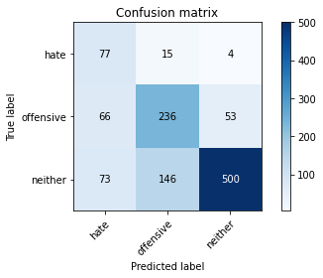

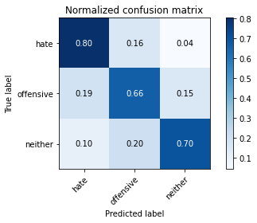

precision recall f1-score support

hate 0.36 0.80 0.49 96

offensive 0.59 0.66 0.63 355

neither 0.90 0.70 0.78 719

accuracy 0.69 1170

macro avg 0.62 0.72 0.63 1170

weighted avg 0.76 0.69 0.71 1170

average eval_loss: 1.1926584647873701, accuracy: 0.6948717948717948

training 7 epoch...

10.607399463653564 seconds used......

7 training finished! average train loss: 0.039549589165419875

evaluating...

Confusion matrix, without normalization

[[ 84 6 6]

[ 95 203 57]

[ 77 123 519]]

Normalized confusion matrix

[[0.875 0.0625 0.0625 ]

[0.26760563 0.57183099 0.16056338]

[0.10709318 0.17107093 0.72183588]]

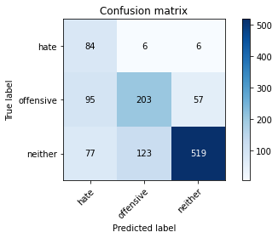

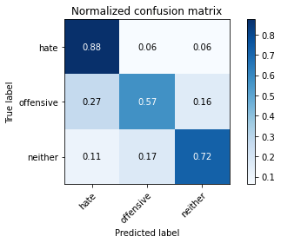

precision recall f1-score support

hate 0.33 0.88 0.48 96

offensive 0.61 0.57 0.59 355

neither 0.89 0.72 0.80 719

accuracy 0.69 1170

macro avg 0.61 0.72 0.62 1170

weighted avg 0.76 0.69 0.71 1170

average eval_loss: 1.2851823967392162, accuracy: 0.6888888888888889

training 8 epoch...

10.52572774887085 seconds used......

8 training finished! average train loss: 0.06408426920201496

evaluating...

Confusion matrix, without normalization

[[ 72 12 12]

[ 71 210 74]

[ 61 110 548]]

Normalized confusion matrix

[[0.75 0.125 0.125 ]

[0.2 0.5915493 0.2084507 ]

[0.08484006 0.15299026 0.76216968]]

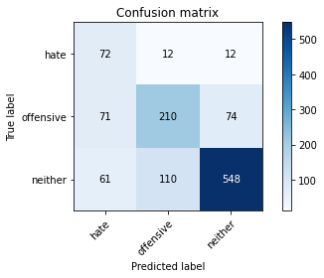

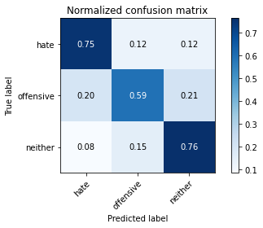

precision recall f1-score support

hate 0.35 0.75 0.48 96

offensive 0.63 0.59 0.61 355

neither 0.86 0.76 0.81 719

accuracy 0.71 1170

macro avg 0.62 0.70 0.63 1170

weighted avg 0.75 0.71 0.72 1170

average eval_loss: 1.1115236095452712, accuracy: 0.7094017094017094

training 9 epoch...

10.632087469100952 seconds used......

9 training finished! average train loss: 0.01325520284756619

evaluating...

Confusion matrix, without normalization

[[ 78 13 5]

[ 67 237 51]

[ 69 141 509]]

Normalized confusion matrix

[[0.8125 0.13541667 0.05208333]

[0.18873239 0.66760563 0.14366197]

[0.09596662 0.1961057 0.70792768]]

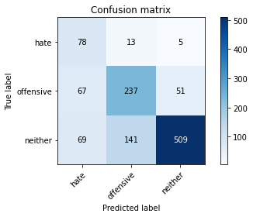

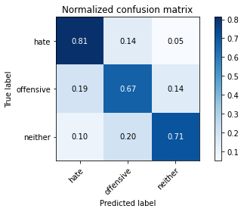

precision recall f1-score support

hate 0.36 0.81 0.50 96

offensive 0.61 0.67 0.64 355

neither 0.90 0.71 0.79 719

accuracy 0.70 1170

macro avg 0.62 0.73 0.64 1170

weighted avg 0.77 0.70 0.72 1170

average eval_loss: 1.3354804720413886, accuracy: 0.7042735042735043

training 10 epoch...

10.55502438545227 seconds used......

10 training finished! average train loss: 0.008025682922120072

evaluating...

Confusion matrix, without normalization

[[ 79 14 3]

[ 73 246 36]

[ 77 182 460]]

Normalized confusion matrix

[[0.82291667 0.14583333 0.03125 ]

[0.2056338 0.69295775 0.10140845]

[0.10709318 0.25312935 0.63977747]]

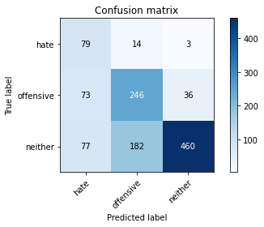

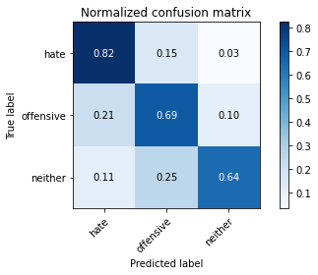

precision recall f1-score support

hate 0.34 0.82 0.49 96

offensive 0.56 0.69 0.62 355

neither 0.92 0.64 0.76 719

accuracy 0.67 1170

macro avg 0.61 0.72 0.62 1170

weighted avg 0.76 0.67 0.69 1170

average eval_loss: 1.6443439333115595, accuracy: 0.6709401709401709

3 run......

training 1 epoch...

10.647666215896606 seconds used......

1 training finished! average train loss: 0.9816880364503179

evaluating...

Confusion matrix, without normalization

[[ 82 11 3]

[111 211 33]

[142 196 381]]

Normalized confusion matrix

[[0.85416667 0.11458333 0.03125 ]

[0.31267606 0.5943662 0.09295775]

[0.19749652 0.27260083 0.52990264]]

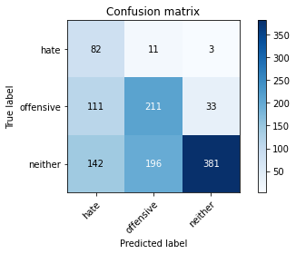

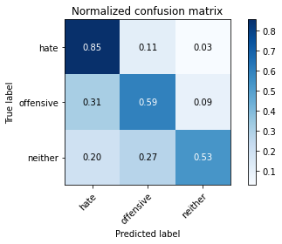

precision recall f1-score support

hate 0.24 0.85 0.38 96

offensive 0.50 0.59 0.55 355

neither 0.91 0.53 0.67 719

accuracy 0.58 1170

macro avg 0.55 0.66 0.53 1170

weighted avg 0.73 0.58 0.61 1170

average eval_loss: 0.9197212700116433, accuracy: 0.576068376068376

training 2 epoch...

10.53979229927063 seconds used......

2 training finished! average train loss: 0.680188061935561

evaluating...

Confusion matrix, without normalization

[[ 47 41 8]

[ 32 286 37]

[ 42 196 481]]

Normalized confusion matrix

[[0.48958333 0.42708333 0.08333333]

[0.09014085 0.8056338 0.10422535]

[0.05841446 0.27260083 0.6689847 ]]

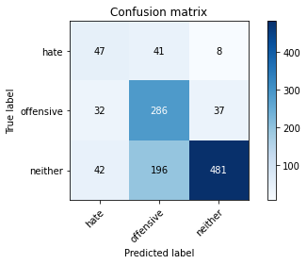

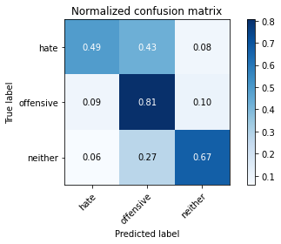

precision recall f1-score support

hate 0.39 0.49 0.43 96

offensive 0.55 0.81 0.65 355

neither 0.91 0.67 0.77 719

accuracy 0.70 1170

macro avg 0.62 0.65 0.62 1170

weighted avg 0.76 0.70 0.71 1170

average eval_loss: 0.7032286898564484, accuracy: 0.6957264957264957

training 3 epoch...

10.613360404968262 seconds used......

3 training finished! average train loss: 0.4176403800291674

evaluating...

Confusion matrix, without normalization

[[ 87 8 1]

[106 230 19]

[132 181 406]]

Normalized confusion matrix

[[0.90625 0.08333333 0.01041667]

[0.29859155 0.64788732 0.05352113]

[0.18358832 0.25173853 0.56467316]]

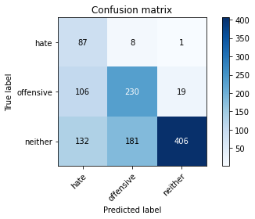

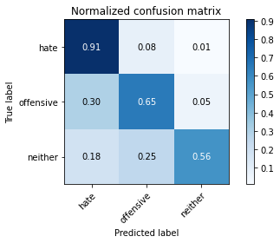

precision recall f1-score support

hate 0.27 0.91 0.41 96

offensive 0.55 0.65 0.59 355

neither 0.95 0.56 0.71 719

accuracy 0.62 1170

macro avg 0.59 0.71 0.57 1170

weighted avg 0.77 0.62 0.65 1170

average eval_loss: 1.0626742011409696, accuracy: 0.617948717948718

training 4 epoch...

10.541539430618286 seconds used......

4 training finished! average train loss: 0.15741892943957023

evaluating...

Confusion matrix, without normalization

[[ 73 16 7]

[ 58 251 46]

[ 68 114 537]]

Normalized confusion matrix

[[0.76041667 0.16666667 0.07291667]

[0.16338028 0.70704225 0.12957746]

[0.0945758 0.15855355 0.74687065]]

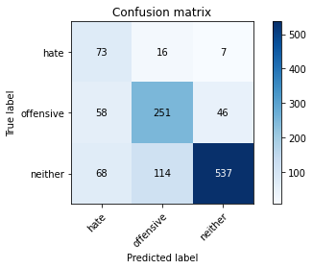

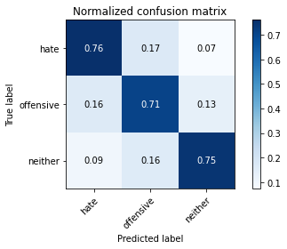

precision recall f1-score support

hate 0.37 0.76 0.49 96

offensive 0.66 0.71 0.68 355

neither 0.91 0.75 0.82 719

accuracy 0.74 1170

macro avg 0.65 0.74 0.67 1170

weighted avg 0.79 0.74 0.75 1170

average eval_loss: 0.8301618051225856, accuracy: 0.735897435897436

training 5 epoch...

10.597833156585693 seconds used......

5 training finished! average train loss: 0.055718242889270186

evaluating...

Confusion matrix, without normalization

[[ 83 6 7]

[ 91 205 59]

[ 74 87 558]]

Normalized confusion matrix

[[0.86458333 0.0625 0.07291667]

[0.25633803 0.57746479 0.16619718]

[0.10292072 0.12100139 0.77607789]]

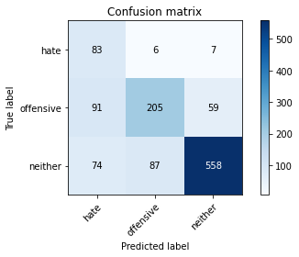

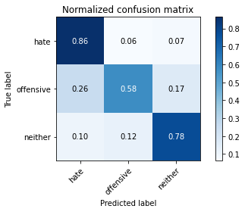

precision recall f1-score support

hate 0.33 0.86 0.48 96

offensive 0.69 0.58 0.63 355

neither 0.89 0.78 0.83 719

accuracy 0.72 1170

macro avg 0.64 0.74 0.65 1170

weighted avg 0.79 0.72 0.74 1170

average eval_loss: 1.052693783984346, accuracy: 0.7230769230769231

training 6 epoch...

10.538249254226685 seconds used......

6 training finished! average train loss: 0.040190371668099294

evaluating...

Confusion matrix, without normalization

[[ 84 9 3]

[ 73 246 36]

[100 135 484]]

Normalized confusion matrix

[[0.875 0.09375 0.03125 ]

[0.2056338 0.69295775 0.10140845]

[0.13908206 0.18776078 0.67315716]]

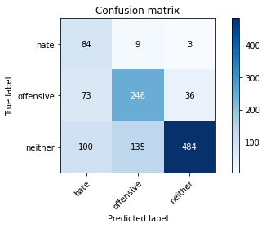

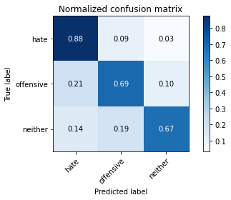

precision recall f1-score support

hate 0.33 0.88 0.48 96

offensive 0.63 0.69 0.66 355

neither 0.93 0.67 0.78 719

accuracy 0.70 1170

macro avg 0.63 0.75 0.64 1170

weighted avg 0.79 0.70 0.72 1170

average eval_loss: 1.2677742705001669, accuracy: 0.6957264957264957

training 7 epoch...

10.570020914077759 seconds used......

7 training finished! average train loss: 0.019549169070419987

evaluating...

Confusion matrix, without normalization

[[ 67 24 5]

[ 43 274 38]

[ 60 163 496]]

Normalized confusion matrix

[[0.69791667 0.25 0.05208333]

[0.12112676 0.77183099 0.10704225]

[0.08344924 0.22670376 0.68984701]]

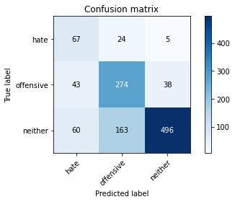

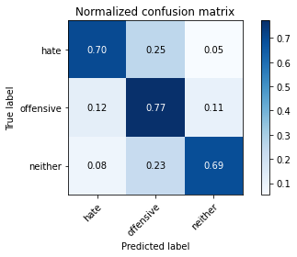

precision recall f1-score support

hate 0.39 0.70 0.50 96

offensive 0.59 0.77 0.67 355

neither 0.92 0.69 0.79 719

accuracy 0.72 1170

macro avg 0.64 0.72 0.65 1170

weighted avg 0.78 0.72 0.73 1170

average eval_loss: 1.2286128515409211, accuracy: 0.7153846153846154

training 8 epoch...

10.505248069763184 seconds used......

8 training finished! average train loss: 0.01739945168083068

evaluating...

Confusion matrix, without normalization

[[ 66 24 6]

[ 53 268 34]

[ 67 150 502]]

Normalized confusion matrix

[[0.6875 0.25 0.0625 ]

[0.14929577 0.75492958 0.09577465]

[0.09318498 0.20862309 0.69819193]]

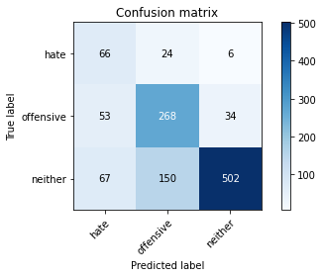

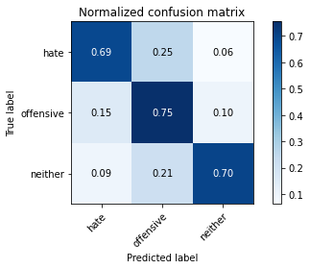

precision recall f1-score support

hate 0.35 0.69 0.47 96

offensive 0.61 0.75 0.67 355

neither 0.93 0.70 0.80 719

accuracy 0.71 1170

macro avg 0.63 0.71 0.65 1170

weighted avg 0.78 0.71 0.73 1170

average eval_loss: 1.416249351986384, accuracy: 0.7145299145299145

training 9 epoch...

10.59568476676941 seconds used......

9 training finished! average train loss: 0.009225619812371275

evaluating...

Confusion matrix, without normalization

[[ 79 13 4]

[ 73 253 29]

[104 171 444]]

Normalized confusion matrix

[[0.82291667 0.13541667 0.04166667]

[0.2056338 0.71267606 0.08169014]

[0.14464534 0.23783032 0.61752434]]

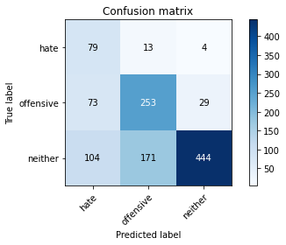

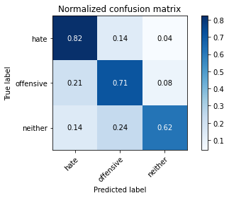

precision recall f1-score support

hate 0.31 0.82 0.45 96

offensive 0.58 0.71 0.64 355

neither 0.93 0.62 0.74 719

accuracy 0.66 1170

macro avg 0.61 0.72 0.61 1170

weighted avg 0.77 0.66 0.69 1170

average eval_loss: 1.703572406102035, accuracy: 0.6632478632478632

training 10 epoch...

10.488170146942139 seconds used......

10 training finished! average train loss: 0.03977937710338405

evaluating...

Confusion matrix, without normalization

[[ 92 3 1]

[165 172 18]

[209 117 393]]

Normalized confusion matrix

[[0.95833333 0.03125 0.01041667]

[0.46478873 0.48450704 0.05070423]

[0.2906815 0.16272601 0.54659249]]

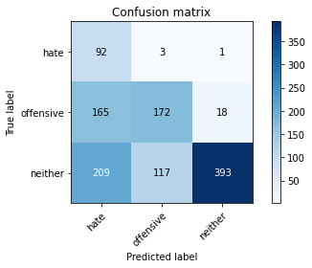

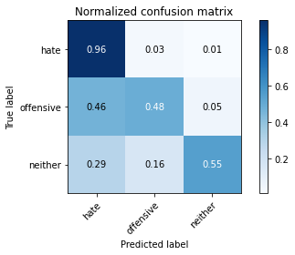

precision recall f1-score support

hate 0.20 0.96 0.33 96

offensive 0.59 0.48 0.53 355

neither 0.95 0.55 0.69 719

accuracy 0.56 1170

macro avg 0.58 0.66 0.52 1170

weighted avg 0.78 0.56 0.62 1170

average eval_loss: 2.206468809459169, accuracy: 0.5615384615384615

4 run......

training 1 epoch...

10.586282014846802 seconds used......

1 training finished! average train loss: 1.0204150080680847

evaluating...

Confusion matrix, without normalization

[[ 68 23 5]

[ 99 199 57]

[ 95 138 486]]

Normalized confusion matrix

[[0.70833333 0.23958333 0.05208333]

[0.27887324 0.56056338 0.16056338]

[0.13212796 0.19193324 0.6759388 ]]

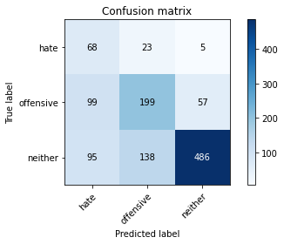

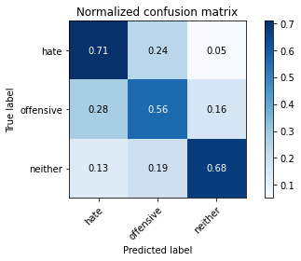

precision recall f1-score support

hate 0.26 0.71 0.38 96

offensive 0.55 0.56 0.56 355

neither 0.89 0.68 0.77 719

accuracy 0.64 1170

macro avg 0.57 0.65 0.57 1170

weighted avg 0.73 0.64 0.67 1170

average eval_loss: 0.817772575354172, accuracy: 0.6435897435897436

training 2 epoch...

10.538044214248657 seconds used......

2 training finished! average train loss: 0.7080301227314132

evaluating...

Confusion matrix, without normalization

[[ 64 19 13]

[ 48 204 103]

[ 43 71 605]]

Normalized confusion matrix

[[0.66666667 0.19791667 0.13541667]

[0.13521127 0.57464789 0.29014085]

[0.05980529 0.09874826 0.84144645]]

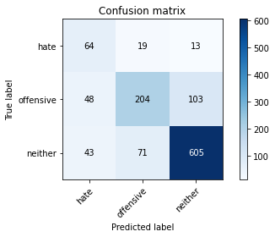

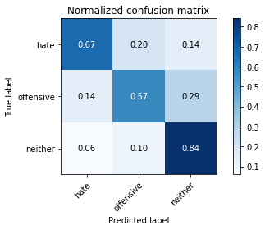

precision recall f1-score support

hate 0.41 0.67 0.51 96

offensive 0.69 0.57 0.63 355

neither 0.84 0.84 0.84 719

accuracy 0.75 1170

macro avg 0.65 0.69 0.66 1170

weighted avg 0.76 0.75 0.75 1170

average eval_loss: 0.5994768885232634, accuracy: 0.7461538461538462

training 3 epoch...

10.53664255142212 seconds used......

3 training finished! average train loss: 0.4477246981114149

evaluating...

Confusion matrix, without normalization

[[ 74 20 2]

[ 72 251 32]

[ 81 179 459]]

Normalized confusion matrix

[[0.77083333 0.20833333 0.02083333]

[0.2028169 0.70704225 0.09014085]

[0.11265647 0.24895688 0.63838665]]

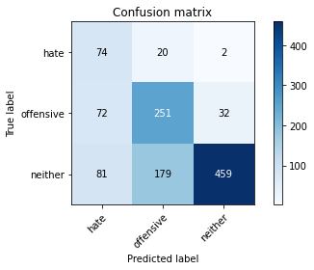

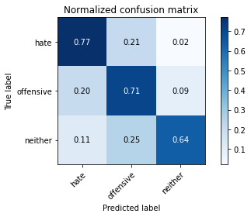

precision recall f1-score support

hate 0.33 0.77 0.46 96

offensive 0.56 0.71 0.62 355

neither 0.93 0.64 0.76 719

accuracy 0.67 1170

macro avg 0.60 0.71 0.61 1170

weighted avg 0.77 0.67 0.69 1170

average eval_loss: 0.8697932332249011, accuracy: 0.67008547008547

training 4 epoch...

10.513029098510742 seconds used......

4 training finished! average train loss: 0.2035732944495976

evaluating...

Confusion matrix, without normalization

[[ 77 7 12]

[ 64 186 105]

[ 49 68 602]]

Normalized confusion matrix

[[0.80208333 0.07291667 0.125 ]

[0.18028169 0.52394366 0.29577465]

[0.06815021 0.0945758 0.83727399]]

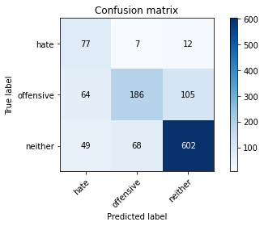

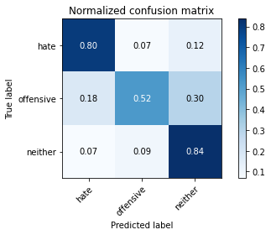

precision recall f1-score support

hate 0.41 0.80 0.54 96

offensive 0.71 0.52 0.60 355

neither 0.84 0.84 0.84 719

accuracy 0.74 1170

macro avg 0.65 0.72 0.66 1170

weighted avg 0.76 0.74 0.74 1170

average eval_loss: 0.7099595039577807, accuracy: 0.7393162393162394

training 5 epoch...

10.494181394577026 seconds used......

5 training finished! average train loss: 0.09425903334548431

evaluating...

Confusion matrix, without normalization

[[ 76 17 3]

[ 62 256 37]

[ 68 186 465]]

Normalized confusion matrix

[[0.79166667 0.17708333 0.03125 ]

[0.17464789 0.72112676 0.10422535]

[0.0945758 0.25869263 0.64673157]]

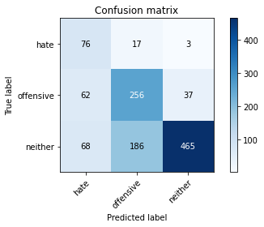

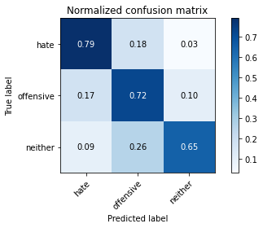

precision recall f1-score support

hate 0.37 0.79 0.50 96

offensive 0.56 0.72 0.63 355

neither 0.92 0.65 0.76 719

accuracy 0.68 1170

macro avg 0.62 0.72 0.63 1170

weighted avg 0.77 0.68 0.70 1170

average eval_loss: 1.1239054230815273, accuracy: 0.6811965811965812

training 6 epoch...

10.51709794998169 seconds used......

6 training finished! average train loss: 0.03547138314960258

evaluating...

Confusion matrix, without normalization

[[ 91 3 2]

[112 198 45]

[ 97 117 505]]

Normalized confusion matrix

[[0.94791667 0.03125 0.02083333]

[0.31549296 0.55774648 0.12676056]

[0.1349096 0.16272601 0.70236439]]

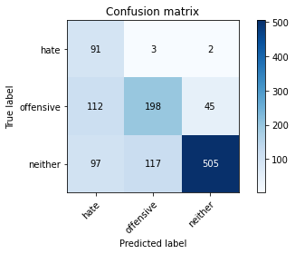

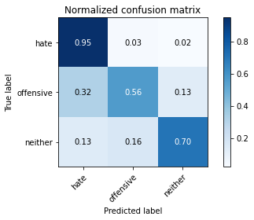

precision recall f1-score support

hate 0.30 0.95 0.46 96

offensive 0.62 0.56 0.59 355

neither 0.91 0.70 0.79 719

accuracy 0.68 1170

macro avg 0.61 0.74 0.61 1170

weighted avg 0.78 0.68 0.70 1170

average eval_loss: 1.3606149640123724, accuracy: 0.6786324786324787

training 7 epoch...

10.507455587387085 seconds used......

7 training finished! average train loss: 0.0219301237999129

evaluating...

Confusion matrix, without normalization

[[ 80 15 1]

[ 72 256 27]

[ 79 193 447]]

Normalized confusion matrix

[[0.83333333 0.15625 0.01041667]

[0.2028169 0.72112676 0.07605634]

[0.10987483 0.26842837 0.6216968 ]]

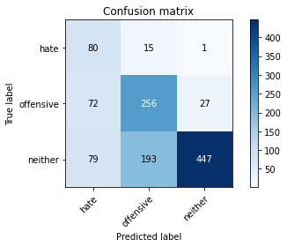

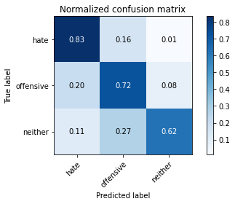

precision recall f1-score support

hate 0.35 0.83 0.49 96

offensive 0.55 0.72 0.63 355

neither 0.94 0.62 0.75 719

accuracy 0.67 1170

macro avg 0.61 0.73 0.62 1170

weighted avg 0.77 0.67 0.69 1170

average eval_loss: 1.5084116064896018, accuracy: 0.6692307692307692

training 8 epoch...

10.505760431289673 seconds used......

8 training finished! average train loss: 0.026704240338793688

evaluating...

Confusion matrix, without normalization

[[ 66 24 6]

[ 57 224 74]

[ 51 115 553]]

Normalized confusion matrix

[[0.6875 0.25 0.0625 ]

[0.16056338 0.63098592 0.2084507 ]

[0.07093185 0.15994437 0.76912378]]

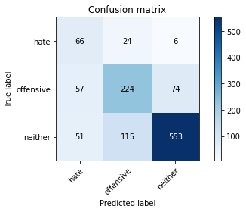

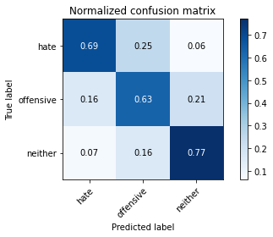

precision recall f1-score support

hate 0.38 0.69 0.49 96

offensive 0.62 0.63 0.62 355

neither 0.87 0.77 0.82 719

accuracy 0.72 1170

macro avg 0.62 0.70 0.64 1170

weighted avg 0.76 0.72 0.73 1170

average eval_loss: 1.0741516740645392, accuracy: 0.7205128205128205

training 9 epoch...

10.54128623008728 seconds used......

9 training finished! average train loss: 0.013882112591610556

evaluating...

Confusion matrix, without normalization

[[ 84 12 0]

[ 71 258 26]

[ 97 179 443]]

Normalized confusion matrix

[[0.875 0.125 0. ]

[0.2 0.72676056 0.07323944]

[0.1349096 0.24895688 0.61613352]]

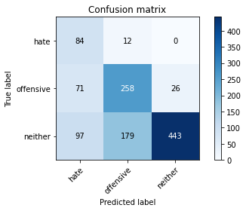

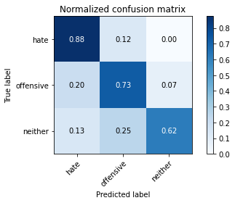

precision recall f1-score support

hate 0.33 0.88 0.48 96

offensive 0.57 0.73 0.64 355

neither 0.94 0.62 0.75 719

accuracy 0.67 1170

macro avg 0.62 0.74 0.62 1170

weighted avg 0.78 0.67 0.69 1170

average eval_loss: 1.7063967338052846, accuracy: 0.6709401709401709

training 10 epoch...

10.555840730667114 seconds used......

10 training finished! average train loss: 0.006608726633463188

evaluating...

Confusion matrix, without normalization

[[ 91 3 2]

[100 205 50]

[ 99 101 519]]

Normalized confusion matrix

[[0.94791667 0.03125 0.02083333]

[0.28169014 0.57746479 0.14084507]

[0.13769124 0.14047288 0.72183588]]

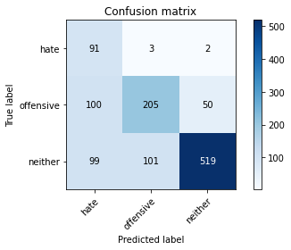

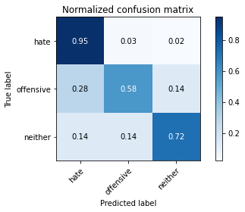

precision recall f1-score support

hate 0.31 0.95 0.47 96

offensive 0.66 0.58 0.62 355

neither 0.91 0.72 0.80 719

accuracy 0.70 1170

macro avg 0.63 0.75 0.63 1170

weighted avg 0.79 0.70 0.72 1170

average eval_loss: 1.6137816006854429, accuracy: 0.6965811965811965

5 run......

training 1 epoch...

10.517008543014526 seconds used......

1 training finished! average train loss: 0.9870247106466975

evaluating...

Confusion matrix, without normalization

[[ 71 3 22]

[106 100 149]

[ 55 28 636]]

Normalized confusion matrix

[[0.73958333 0.03125 0.22916667]

[0.29859155 0.28169014 0.41971831]

[0.07649513 0.03894298 0.88456189]]

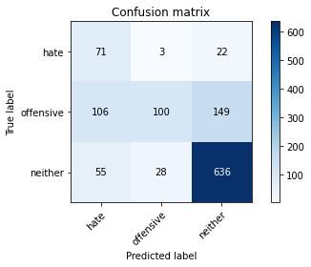

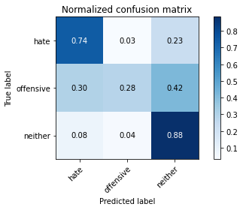

precision recall f1-score support

hate 0.31 0.74 0.43 96

offensive 0.76 0.28 0.41 355

neither 0.79 0.88 0.83 719

accuracy 0.69 1170

macro avg 0.62 0.64 0.56 1170

weighted avg 0.74 0.69 0.67 1170

average eval_loss: 0.6974452213715698, accuracy: 0.6897435897435897

training 2 epoch...

10.499269723892212 seconds used......

2 training finished! average train loss: 0.6397055701485702

evaluating...

Confusion matrix, without normalization

[[ 86 10 0]

[ 92 233 30]

[117 136 466]]

Normalized confusion matrix

[[0.89583333 0.10416667 0. ]

[0.25915493 0.65633803 0.08450704]

[0.16272601 0.1891516 0.64812239]]

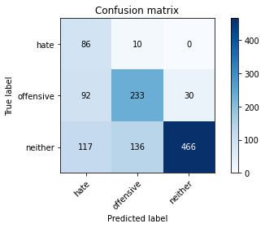

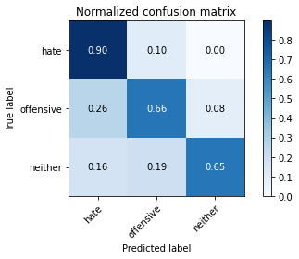

precision recall f1-score support

hate 0.29 0.90 0.44 96

offensive 0.61 0.66 0.63 355

neither 0.94 0.65 0.77 719

accuracy 0.67 1170

macro avg 0.62 0.73 0.61 1170

weighted avg 0.79 0.67 0.70 1170

average eval_loss: 0.8098980567212832, accuracy: 0.6709401709401709

training 3 epoch...

10.512481451034546 seconds used......

3 training finished! average train loss: 0.3159909217751452

evaluating...

Confusion matrix, without normalization

[[ 87 2 7]

[103 189 63]

[ 95 61 563]]

Normalized confusion matrix

[[0.90625 0.02083333 0.07291667]

[0.29014085 0.53239437 0.17746479]

[0.13212796 0.08484006 0.78303199]]

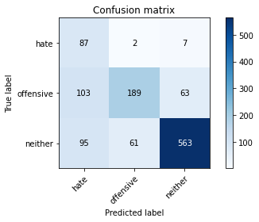

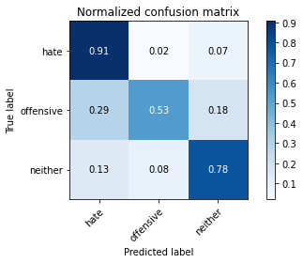

precision recall f1-score support

hate 0.31 0.91 0.46 96

offensive 0.75 0.53 0.62 355

neither 0.89 0.78 0.83 719

accuracy 0.72 1170

macro avg 0.65 0.74 0.64 1170

weighted avg 0.80 0.72 0.74 1170

average eval_loss: 0.7830876975746478, accuracy: 0.7170940170940171

training 4 epoch...

10.511216163635254 seconds used......

4 training finished! average train loss: 0.1302481448011739

evaluating...

Confusion matrix, without normalization

[[ 85 5 6]

[ 91 215 49]

[ 74 97 548]]

Normalized confusion matrix

[[0.88541667 0.05208333 0.0625 ]

[0.25633803 0.6056338 0.13802817]

[0.10292072 0.1349096 0.76216968]]

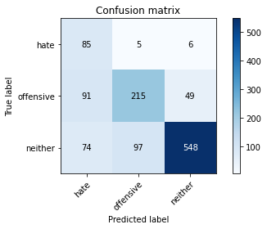

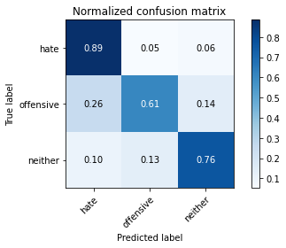

precision recall f1-score support

hate 0.34 0.89 0.49 96

offensive 0.68 0.61 0.64 355

neither 0.91 0.76 0.83 719

accuracy 0.72 1170

macro avg 0.64 0.75 0.65 1170

weighted avg 0.79 0.72 0.74 1170

average eval_loss: 0.8884480754702778, accuracy: 0.7247863247863248

training 5 epoch...

10.509366750717163 seconds used......

5 training finished! average train loss: 0.06467888768695827

evaluating...

Confusion matrix, without normalization

[[ 82 11 3]

[ 69 257 29]

[ 84 167 468]]

Normalized confusion matrix

[[0.85416667 0.11458333 0.03125 ]

[0.1943662 0.72394366 0.08169014]

[0.11682893 0.23226704 0.65090403]]

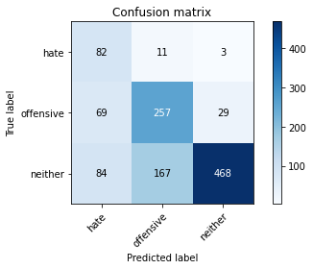

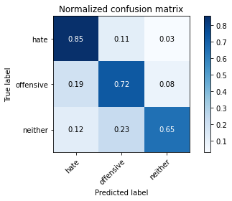

precision recall f1-score support

hate 0.35 0.85 0.50 96

offensive 0.59 0.72 0.65 355

neither 0.94 0.65 0.77 719

accuracy 0.69 1170

macro avg 0.63 0.74 0.64 1170

weighted avg 0.78 0.69 0.71 1170

average eval_loss: 1.1689614577818725, accuracy: 0.6897435897435897

training 6 epoch...

10.48414659500122 seconds used......

6 training finished! average train loss: 0.025934092675535276

evaluating...

Confusion matrix, without normalization

[[ 87 4 5]

[104 204 47]

[ 92 105 522]]

Normalized confusion matrix

[[0.90625 0.04166667 0.05208333]

[0.29295775 0.57464789 0.13239437]

[0.12795549 0.14603616 0.72600834]]

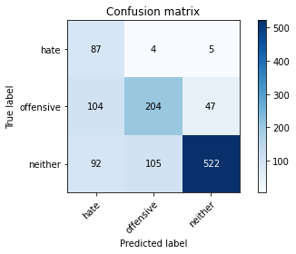

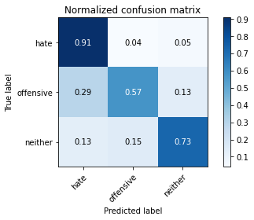

precision recall f1-score support

hate 0.31 0.91 0.46 96

offensive 0.65 0.57 0.61 355

neither 0.91 0.73 0.81 719

accuracy 0.69 1170

macro avg 0.62 0.74 0.63 1170

weighted avg 0.78 0.69 0.72 1170

average eval_loss: 1.3087673270601337, accuracy: 0.6948717948717948

training 7 epoch...

10.537248134613037 seconds used......

7 training finished! average train loss: 0.019192604231648147

evaluating...

Confusion matrix, without normalization

[[ 86 6 4]

[ 96 220 39]

[105 122 492]]

Normalized confusion matrix

[[0.89583333 0.0625 0.04166667]

[0.27042254 0.61971831 0.10985915]

[0.14603616 0.16968011 0.68428373]]

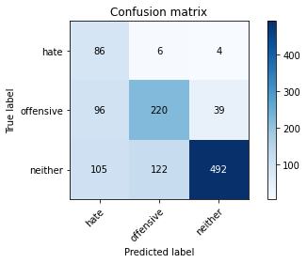

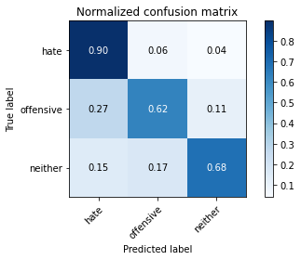

precision recall f1-score support

hate 0.30 0.90 0.45 96

offensive 0.63 0.62 0.63 355

neither 0.92 0.68 0.78 719

accuracy 0.68 1170

macro avg 0.62 0.73 0.62 1170

weighted avg 0.78 0.68 0.71 1170

average eval_loss: 1.4508149580303895, accuracy: 0.6820512820512821

training 8 epoch...

10.6042640209198 seconds used......

8 training finished! average train loss: 0.016133947961082282

evaluating...

Confusion matrix, without normalization

[[ 80 12 4]

[ 64 252 39]

[ 83 140 496]]

Normalized confusion matrix

[[0.83333333 0.125 0.04166667]

[0.18028169 0.70985915 0.10985915]

[0.11543811 0.19471488 0.68984701]]

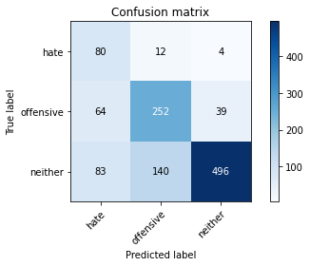

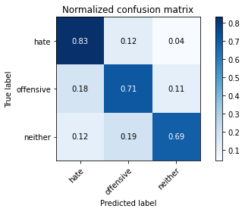

precision recall f1-score support

hate 0.35 0.83 0.50 96

offensive 0.62 0.71 0.66 355

neither 0.92 0.69 0.79 719

accuracy 0.71 1170

macro avg 0.63 0.74 0.65 1170

weighted avg 0.78 0.71 0.73 1170

average eval_loss: 1.263560223503638, accuracy: 0.7076923076923077

training 9 epoch...

10.499959945678711 seconds used......

9 training finished! average train loss: 0.019506206189232347

evaluating...

Confusion matrix, without normalization

[[ 79 12 5]

[ 59 260 36]

[ 65 151 503]]

Normalized confusion matrix

[[0.82291667 0.125 0.05208333]

[0.16619718 0.73239437 0.10140845]

[0.09040334 0.21001391 0.69958275]]

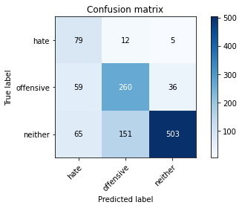

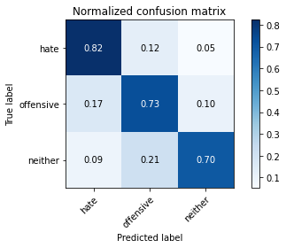

precision recall f1-score support

hate 0.39 0.82 0.53 96

offensive 0.61 0.73 0.67 355

neither 0.92 0.70 0.80 719

accuracy 0.72 1170

macro avg 0.64 0.75 0.66 1170

weighted avg 0.79 0.72 0.74 1170

average eval_loss: 1.2007957389736075, accuracy: 0.7196581196581197

training 10 epoch...

10.601043224334717 seconds used......

10 training finished! average train loss: 0.021913663571467623

evaluating...

Confusion matrix, without normalization

[[ 72 17 7]

[ 46 267 42]

[ 60 127 532]]

Normalized confusion matrix

[[0.75 0.17708333 0.07291667]

[0.12957746 0.75211268 0.11830986]

[0.08344924 0.17663421 0.73991655]]

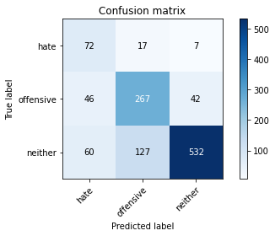

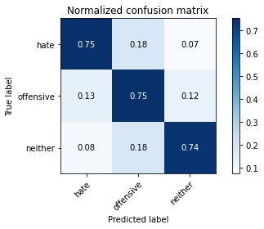

precision recall f1-score support

hate 0.40 0.75 0.53 96

offensive 0.65 0.75 0.70 355

neither 0.92 0.74 0.82 719

accuracy 0.74 1170

macro avg 0.66 0.75 0.68 1170

weighted avg 0.79 0.74 0.76 1170

average eval_loss: 1.197184611806425, accuracy: 0.7444444444444445